Install SQL 2019 Development Edition

Database Engine, SSRS, SSIS, SSAS Tabular, SSMS

Dowload Developer Edition

https://www.microsoft.com/en-us/sql-server/sql-server-downloads

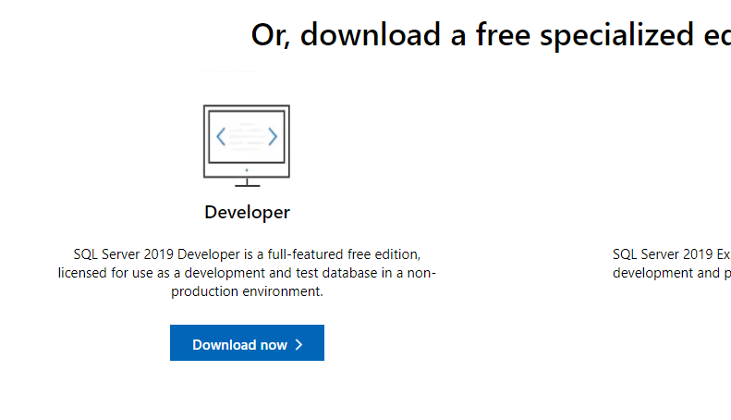

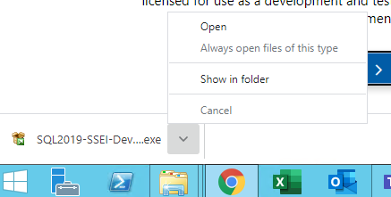

Download

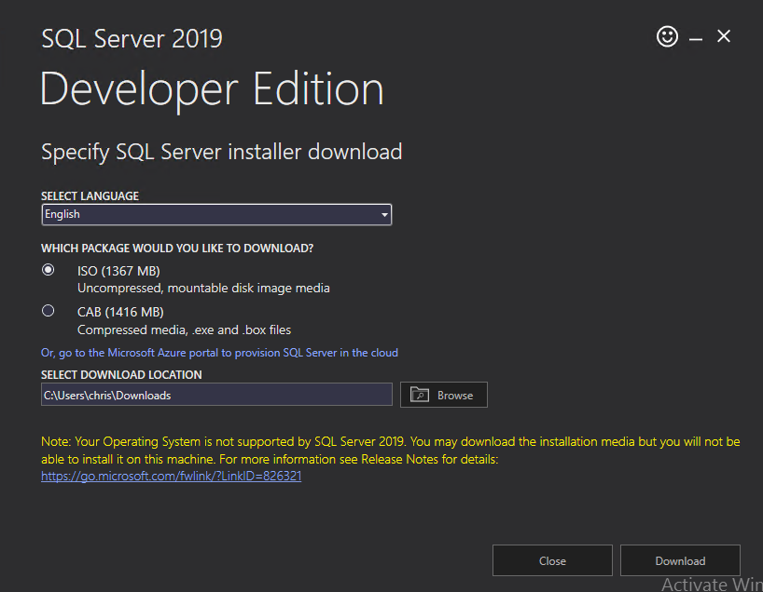

Select Custom

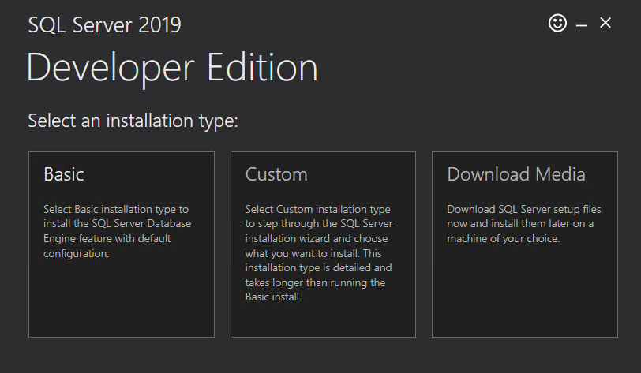

Install

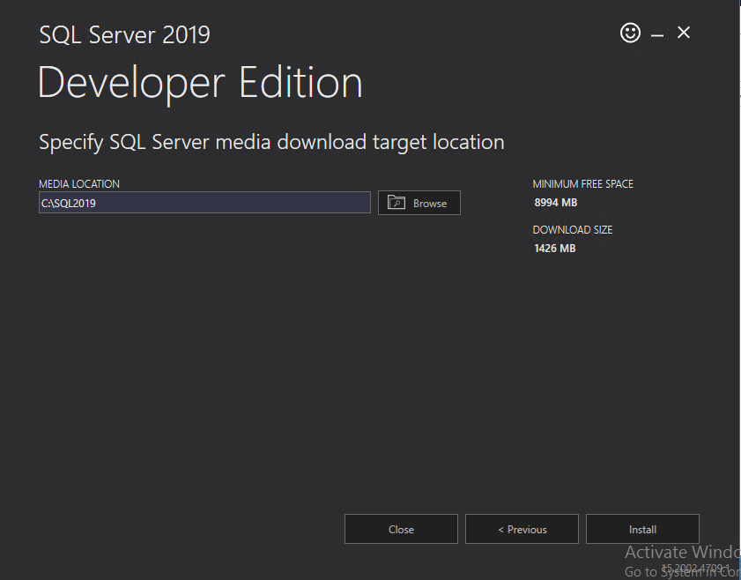

Select Installation, then select New SQL Server stand-alone installation

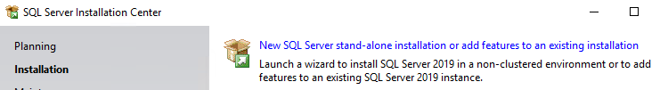

Make sure Specify a free Addition is Developer, then select next

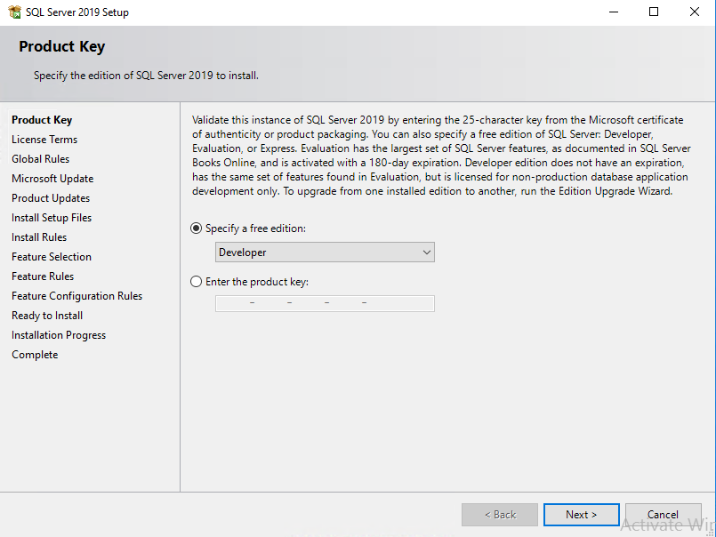

Accept the license and terms then select next

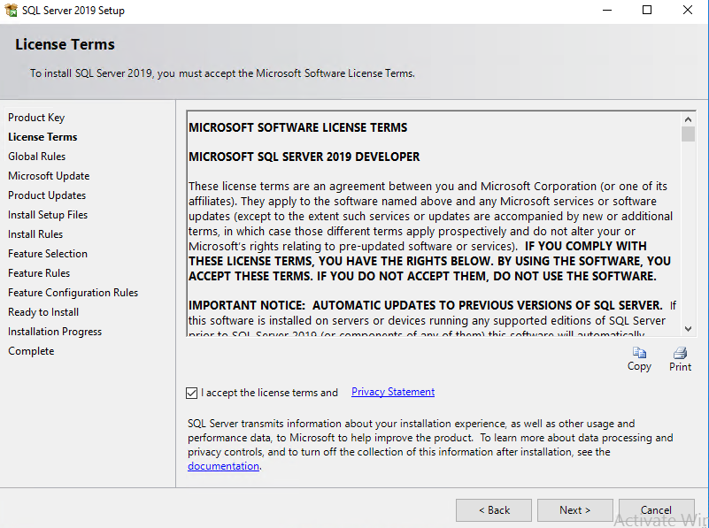

Select next

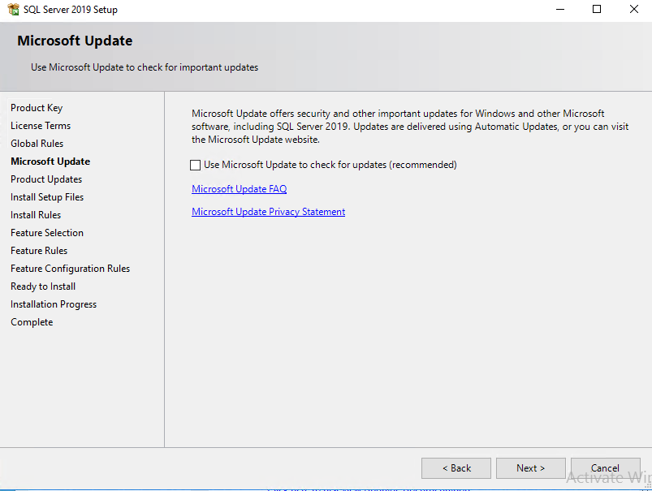

Select Next, Ignore windows Firewall for now

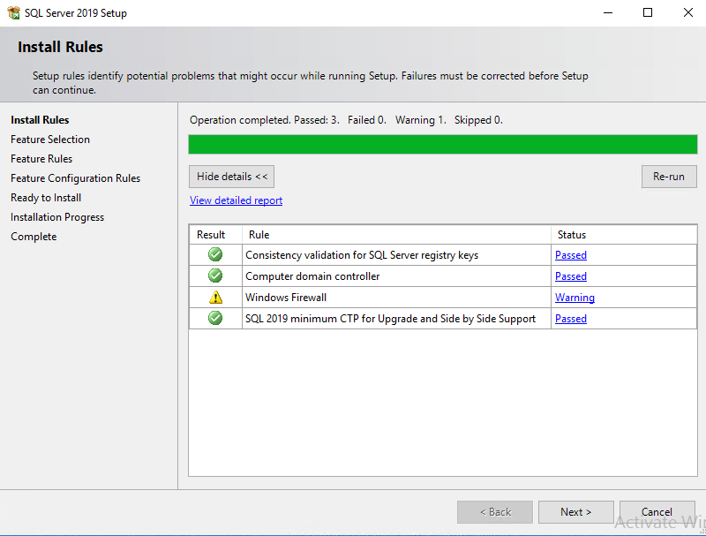

AC

Next

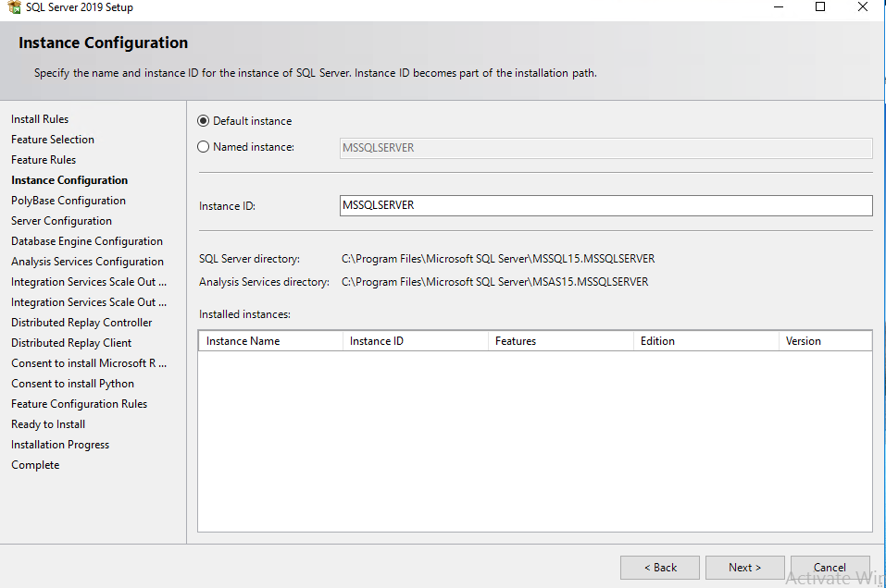

Next

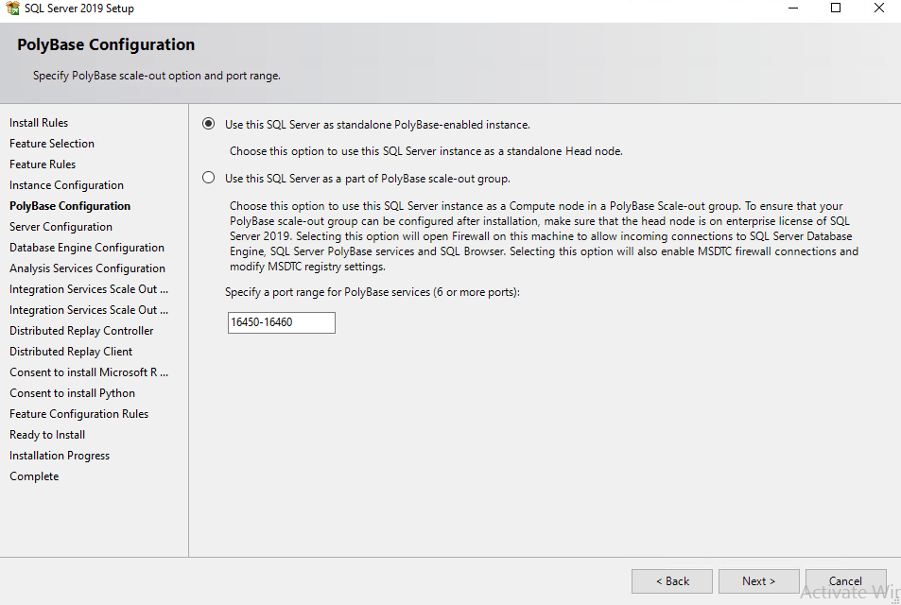

Next

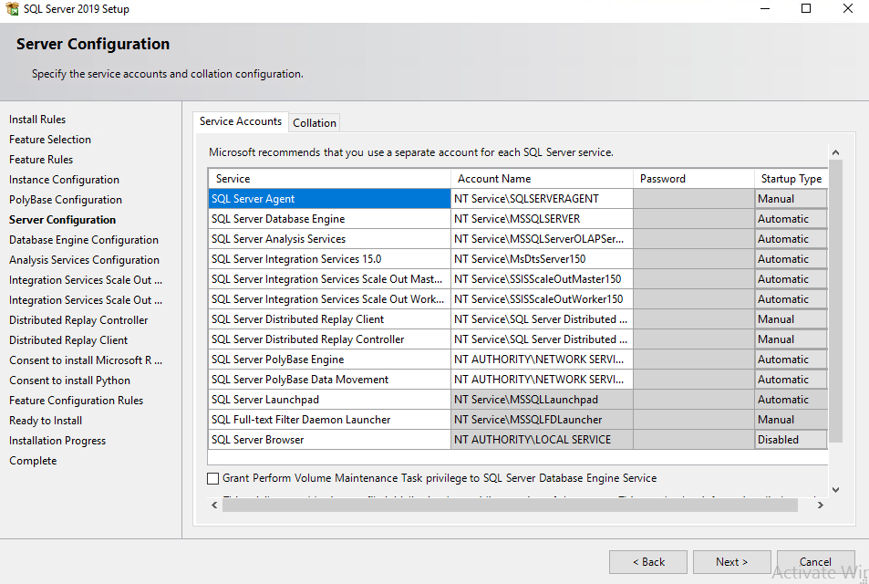

Select Mixed Mode, Enter password for sa, document password. Add current user

Select Data Directories

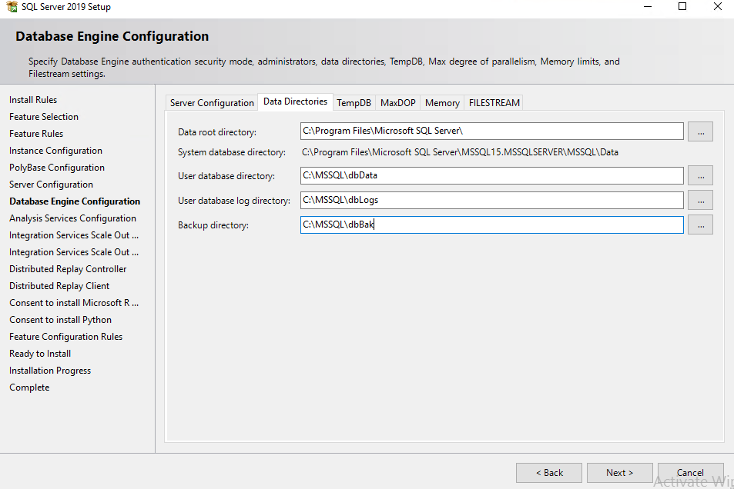

Tabular Mode, add current user

Create Folder Structure

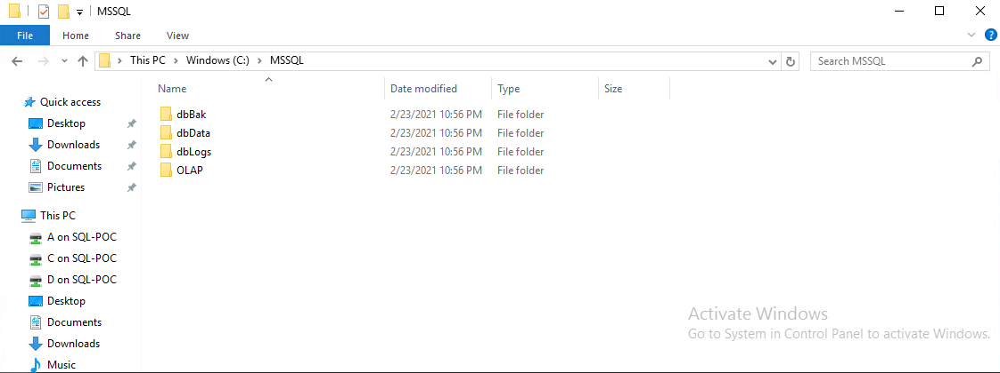

Select Data Directories

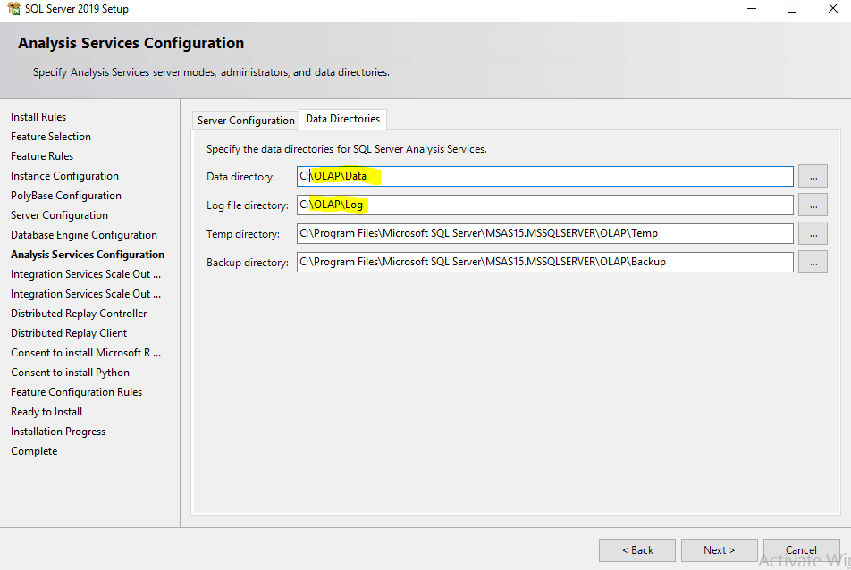

Next

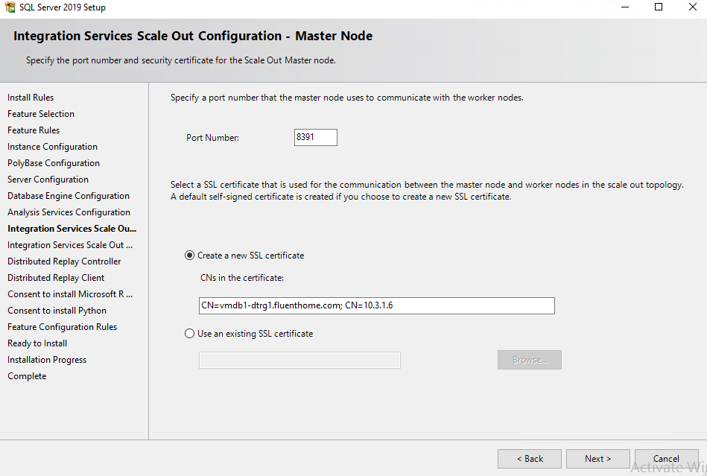



Next

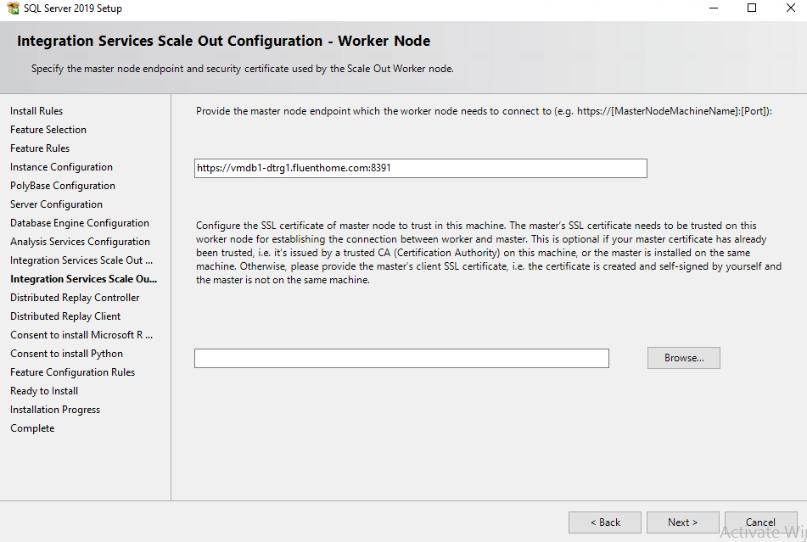



Add controller name, next

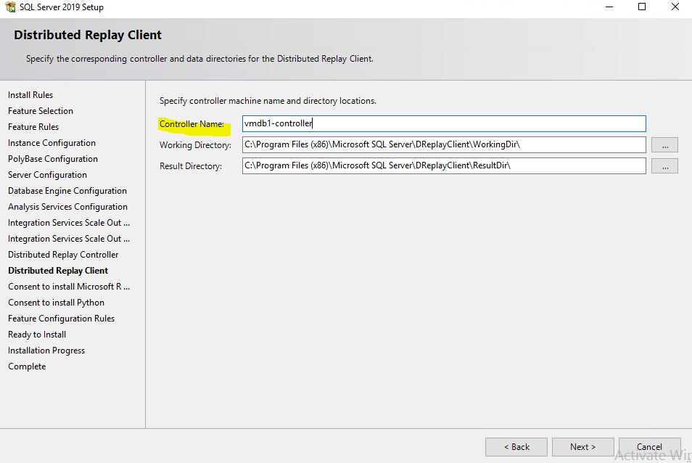

Accept, Next

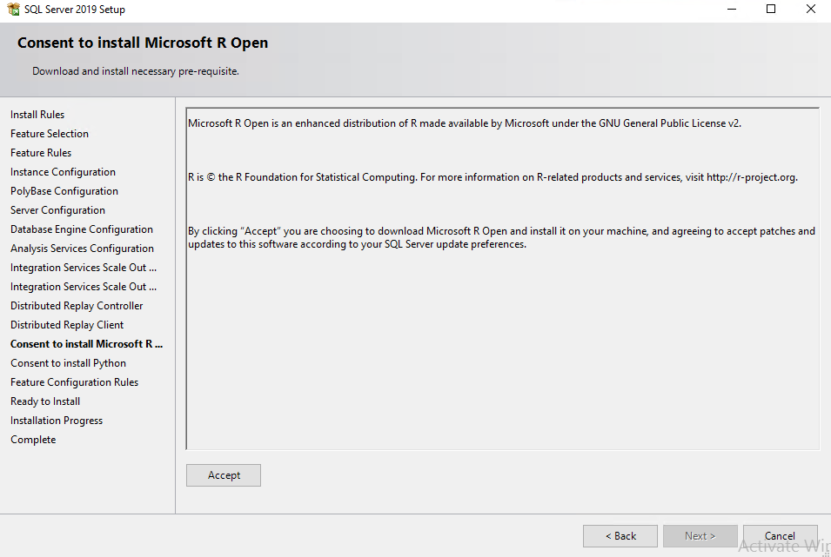

Accept, Next

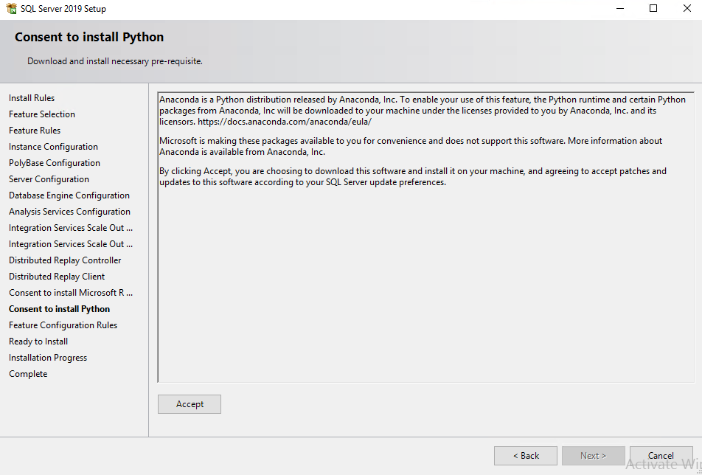

Install

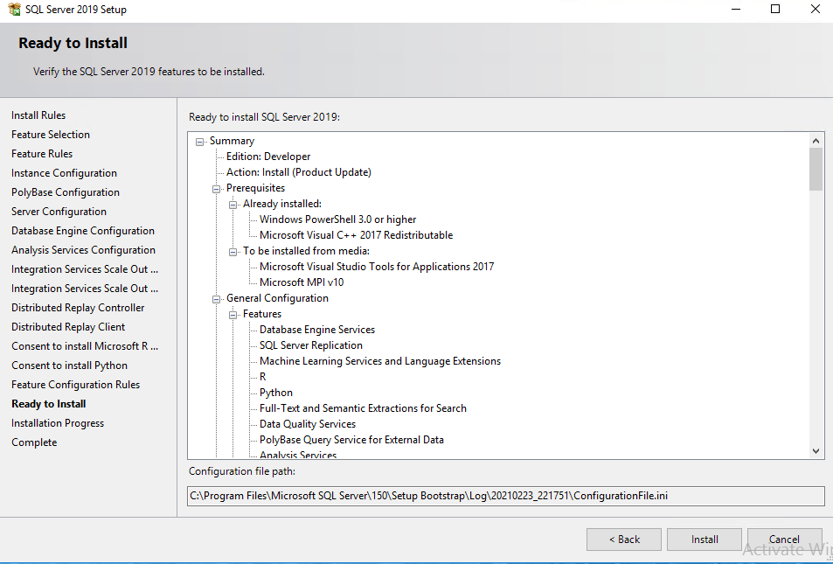

Complete

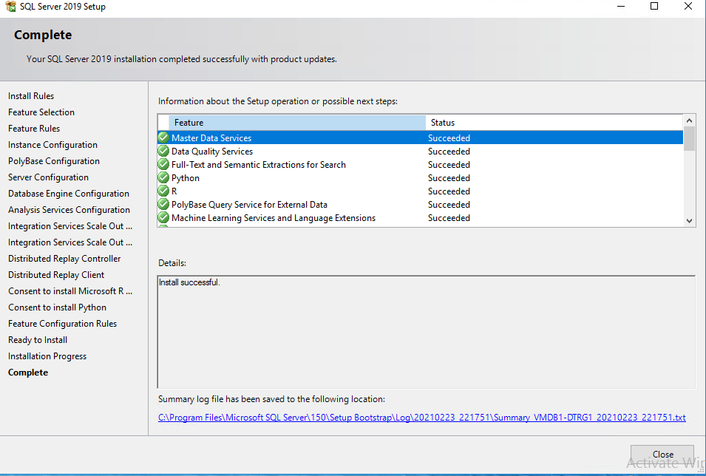

Install SQL Server Reporting Services

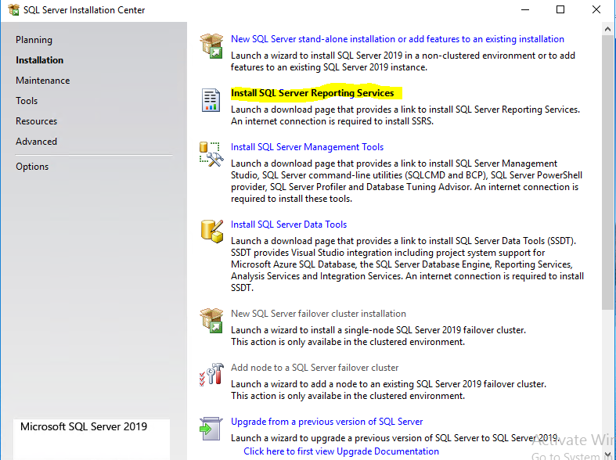

Select SQL Server 2019 Reporting services

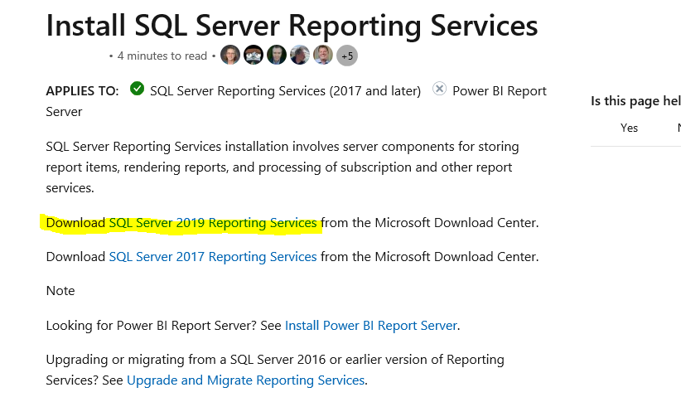

Download

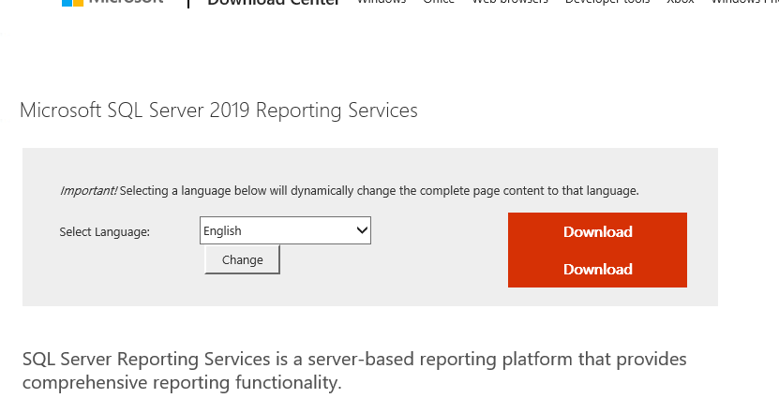

Choose Click here

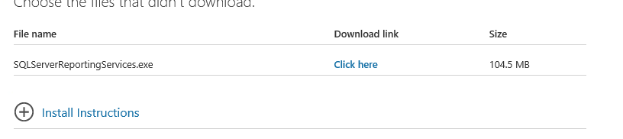

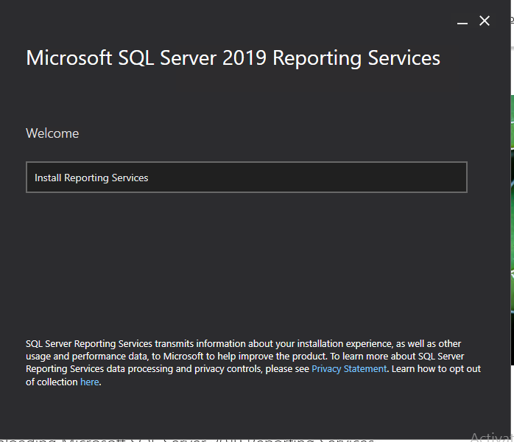

Choose Developer Edition

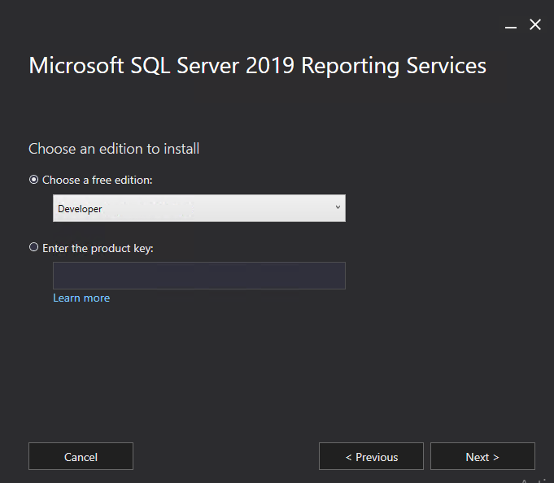

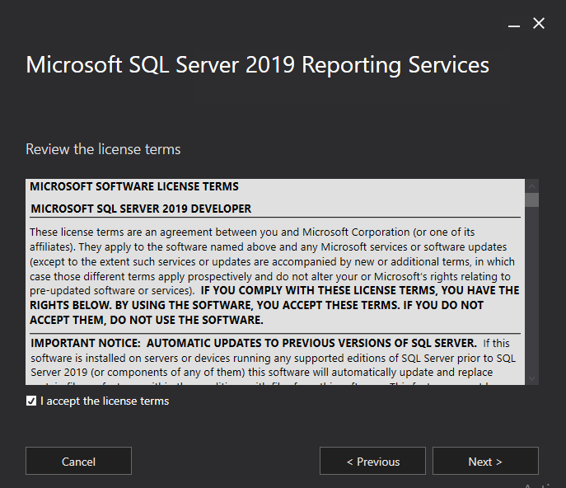

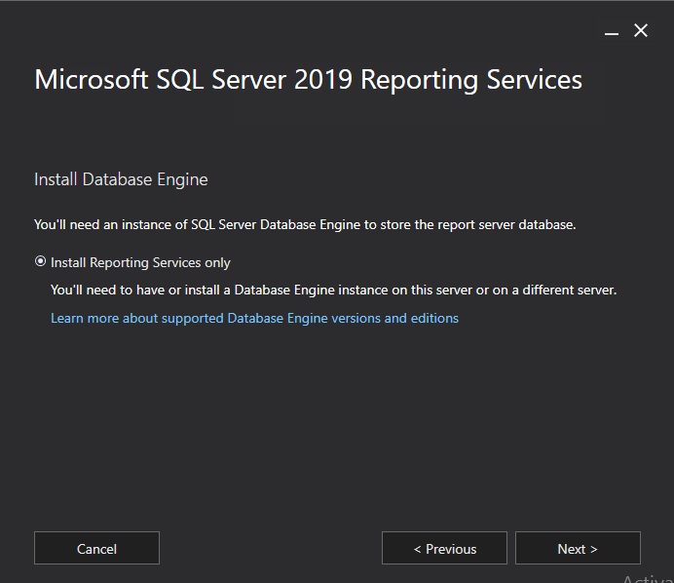

Install

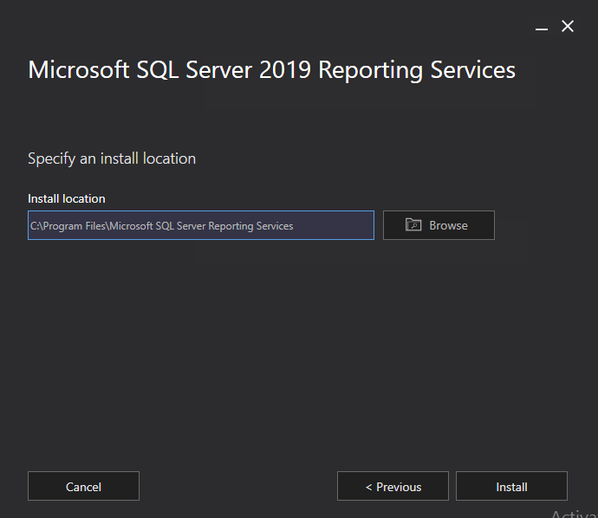

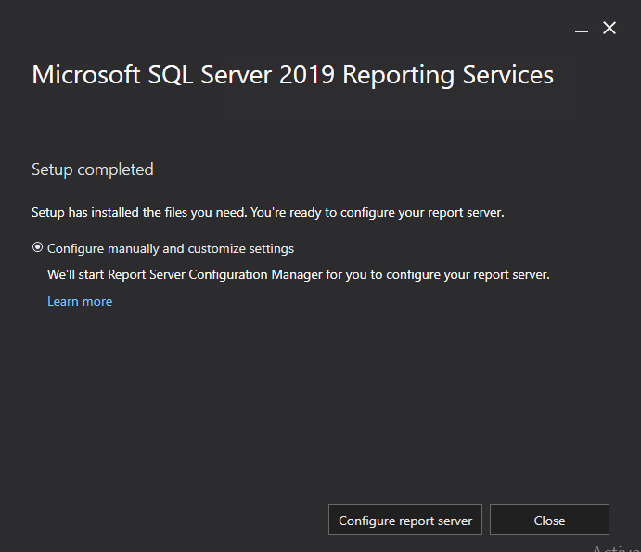

Connect

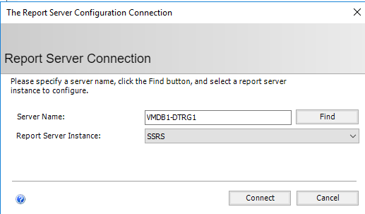

Select apply

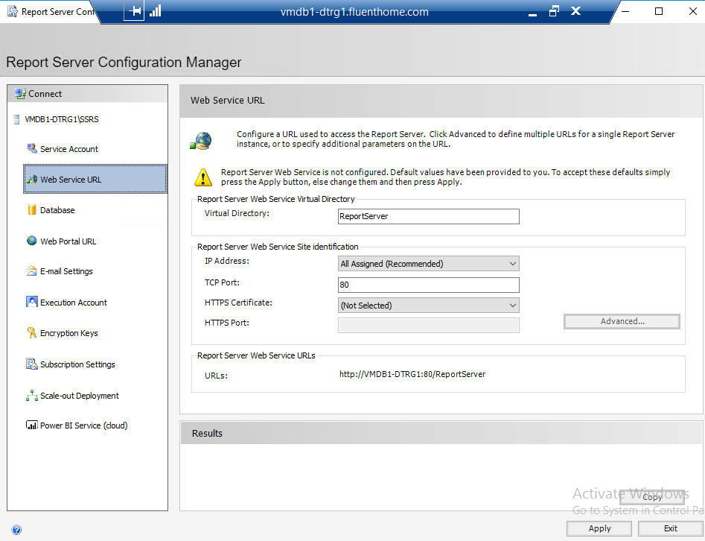

Select apply

Go to Database and select change database

Creste a New report server database, Next

Test Connection, Next

Enter in Database Name, Next

Next

Next

Finish

Apply

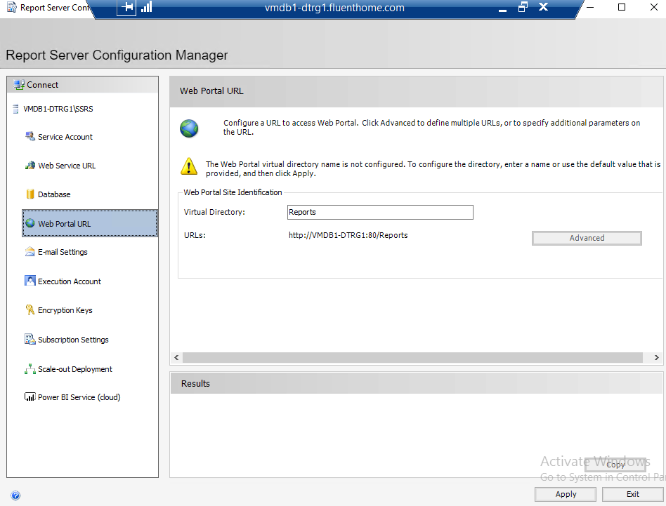

Install SQL Server Management Tools

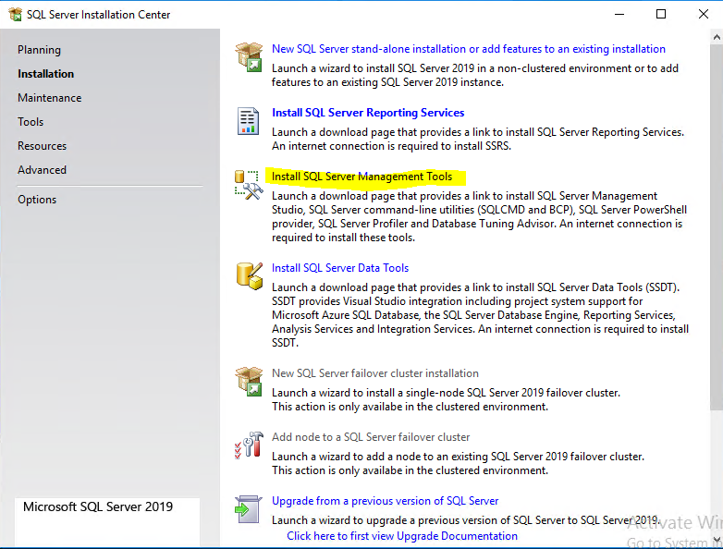

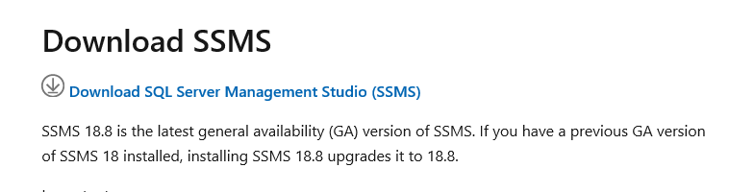

Open Folder



Install

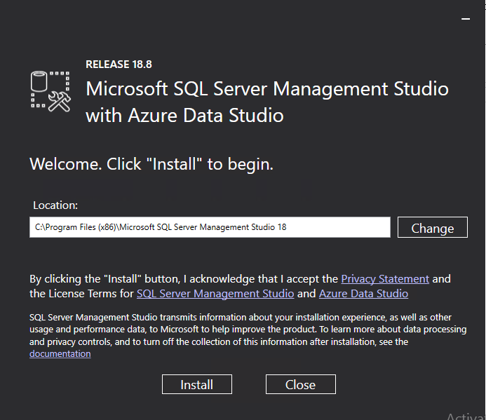

Install SQL Server Data Tools

